**Meteor 012 (2020)**

Stefan Kinne (13 feb 2am)

# Objective

Exploring the larger region around the southern L2 over the entire width of the METEOR assigned area - with regular CTD casts every 3 hours and regular radiosondes launches (at 2.45, 6.45, 10.45, 14.45, 16.33 (DWD), 18.45, 22.45UTC).

In the early morning we reached the L2 site. After a CTD we headed at the L2 latitude of 12.4N towards the eastward boundary to the Meteor region, then diagonally down to the southern track turnaround, diagonally up on the westward boundary at the L2 latitude and finally diagonally up back to the Meteor track for a continuation to L1.

# Synoptic Situation

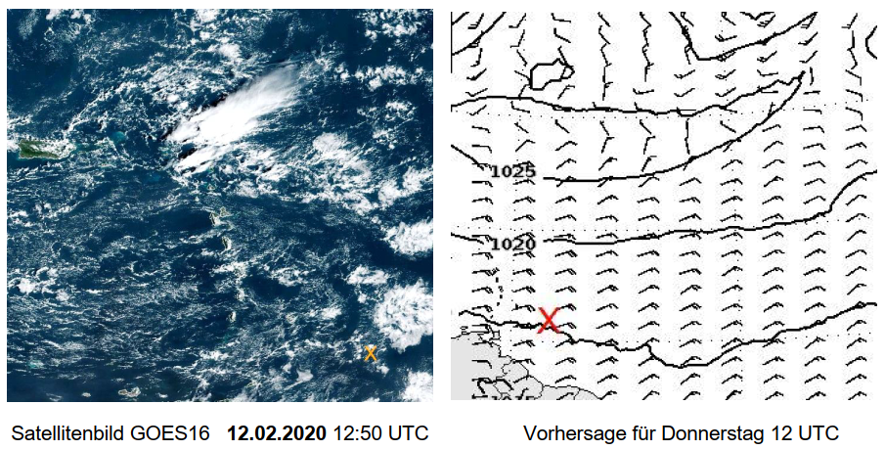

# Weather observations (every 3hr)

20 02 12001 99139 70570 11497 10713 10261 20206 40168 53012 70611 81200 22231 04272 2//// 3//// 4//// 5//// 6//// ICE /////

20 02 12031 99136 70569 46/// /0713 10261 20207 40172 50004 7//// 8//// 22242 04272 2//// 3//// 4//// 5//// 6//// ICE /////

20 02 12061 99131 70571 16/// /0708 10260 20214 40156 58016 7//// 8//// 22242 04272 2//// 3//// 4//// 5//// 6//// ICE /////

20 02 12091 99128 70571 46/// /0811 10261 20204 40150 55006 7//// 8//// 22242 04274 2//// 3//// 4//// 5//// 6//// ICE /////

20 02 12121 99124 70572 11597 70811 10266 20207 40162 53012 70681 86830 22242 04276 20302 306// 40805 5//// 6//// ICE /////

20 02 12151 99124 70571 41597 70811 10266 20199 40171 51009 70382 878// 22221 04275 20302 307// 40805 5//// 6//// ICE /////

20 02 12181 99124 70568 11598 10712 10265 20208 40151 58020 70181 81800 22221 04274 20302 308// 40905 5//// 6//// ICE /////

20 02 12211 99123 70569 41598 10809 10264 20200 40148 55003 70111 81830 22251 04275 20302 307// 40805 5//// 6//// ICE /////

Today passing below ca 2-3km high flower-patches (longer periods of complete cloud cover, then again blue skies for some time. No Cirrus, o rain (possibly a trace early in the morning)., dust AOD is slowly decreasing.

# Cruise-day Elements

IWV (integrated water vapor): 38 kg /m2 +/- 3

LWP (liquid water path): 20 g /m2 +/- 90

|  |  |  |  |  |  |  |  |  |
| --- | --- | --- | --- | --- | --- | --- | --- | --- |
| Time | 0-3UTC | 4-6UTC | 7-9UTC | 10-12UTC | 13-15UTC | 16-18UTC | 19-21UTC | 22-24UTC |
| Height_m | 693.13 | 1050.88 | 782.57 | 737.85 | 760.21 | 1185.03 | 1185.03 | 782.57 |
| max_hydro_frac_low | 0.11 | 0.26 | 0.16 | 0.10 | 0.14 | 0.07 | 0.16 | 0.09 |
| Height_m | 1207.39 | 1207.39 | 1252.11 | 1811.09 | 1833.44 | 1811.09 | 1498.06 | 1207.39 |
| max_hydro_frac_mid | 0.02 | 0.22 | 0.14 | 0.12 | 0.40 | 0.50 | 0.30 | 0.00 |
| Height_m | 12920.65 | 12878.56 | 12836.47 | 12920.65 | 12836.47 | 12836.47 | 12878.56 | 12836.47 |
| max_hydro_frac_high | 0.00 | 0.00 | 0.00 | 0.00 | 0.00 | 0.00 | 0.00 | 0.00 |

low=up to 1200m, mid=up to 6000m, high=up to 15000m

**hourly means of ship data**  (1st line 0-1 UTC, 2nd line 1-2 UTC … last line 23-24 UTC)

salinity Tdew Tair Twater TrueDir RH rel.Wind trueWind lw Rad sw Rad lat lon   
 PSU °C °C °C deg % m/s m/s W/m² W/m² °N °E

|  |  |  |  |  |  |  |  |  |  |  |  |
| --- | --- | --- | --- | --- | --- | --- | --- | --- | --- | --- | --- |
| 35.4383 | 20.69 | 26.15 | 27.13 | 68.1 | 71.57 | 15.16 | 13.23 | 394.58 | -1 | 13.9 | -56.94 |
| 35.4401 | 20.82 | 26.04 | 27.19 | 67.75 | 72.58 | 11.01 | 12.16 | 392.07 | -1 | 13.81 | -56.9 |
| 35.4367 | 20.95 | 26.02 | 27.19 | 67.47 | 73.25 | 10.49 | 11.86 | 400.42 | -1 | 13.64 | -56.94 |
| 35.4274 | 20.73 | 26.1 | 27.21 | 68.27 | 71.9 | 10.51 | 12.14 | 398.18 | -1 | 13.51 | -56.97 |
| 35.4071 | 21.18 | 25.96 | 27.2 | 67.27 | 74.55 | 9.18 | 11.54 | 410.25 | -1 | 13.35 | -57.01 |
| 35.3744 | 20.91 | 25.94 | 27.2 | 69.45 | 73.52 | 10.23 | 11.49 | 409.43 | -1 | 13.19 | -57.05 |
| 35.3704 | 20.65 | 26.19 | 27.22 | 77.67 | 71.2 | 10.31 | 10.91 | 416.68 | -0.95 | 13.06 | -57.08 |
| 35.4056 | 20.48 | 26.16 | 27.32 | 76 | 70.5 | 10.69 | 11.3 | 402.27 | -1 | 12.93 | -57.11 |
| 35.4559 | 20.52 | 26.16 | 27.4 | 77.27 | 70.73 | 10.37 | 10.92 | 393.9 | -1 | 12.82 | -57.13 |
| 35.5188 | 20.74 | 26.16 | 27.47 | 75.7 | 71.75 | 10.29 | 11.04 | 394.98 | -0.98 | 12.69 | -57.16 |
| 35.614 | 20.63 | 26.15 | 27.48 | 72.65 | 71.3 | 11.09 | 11.98 | 405.85 | 29.13 | 12.57 | -57.18 |
| 35.8391 | 20.87 | 26.33 | 27.53 | 75 | 71.53 | 9.59 | 11.14 | 412.85 | 194.57 | 12.46 | -57.22 |
| 35.9028 | 20.79 | 26.4 | 27.57 | 70.53 | 70.9 | 11.09 | 10.69 | 415.07 | 289.53 | 12.42 | -57.25 |
| 35.9054 | 20.46 | 26.54 | 27.54 | 73.13 | 68.85 | 13.26 | 10.96 | 402.08 | 678.3 | 12.42 | -57.22 |
| 35.7704 | 20.59 | 26.56 | 27.49 | 73.08 | 69.37 | 13.95 | 10.43 | 430.58 | 621.6 | 12.42 | -57.1 |
| 35.9521 | 20.3 | 26.65 | 27.48 | 81.4 | 67.7 | 12.73 | 10.76 | 435.72 | 650.92 | 12.42 | -57.01 |
| 35.9347 | 19.85 | 26.69 | 27.48 | 81.78 | 65.82 | 12.21 | 10.67 | 424.18 | 796.43 | 12.42 | -56.98 |
| 35.8765 | 20.34 | 26.56 | 27.4 | 75.3 | 68.28 | 15.94 | 11.59 | 392.92 | 876.27 | 12.42 | -56.87 |
| 35.9405 | 20.45 | 25.86 | 27.38 | 65.33 | 71.83 | 13.96 | 11.95 | 421.8 | 554.22 | 12.42 | -56.75 |
| 35.9364 | 19.95 | 26.44 | 27.45 | 76.87 | 67.27 | 8.54 | 10.55 | 411.87 | 352.73 | 12.4 | -56.75 |
| 35.7978 | 20.44 | 26.49 | 27.5 | 79.98 | 68.88 | 5.43 | 9.63 | 390.4 | 249.67 | 12.33 | -56.88 |
| 35.8343 | 20.35 | 26.45 | 27.41 | 69.5 | 68.82 | 8.94 | 10.02 | 392.18 | 40.57 | 12.28 | -56.99 |
| 35.8613 | 21.15 | 28.03 | 27.42 | 65.03 | 66.23 | 6.08 | 10.09 | 387.4 | -1.55 | 12.24 | -57.04 |
| 35.82 | 21.01 | 26.68 | 27.47 | 67.17 | 70.78 | 6.76 | 10.43 | 395.86 | -1.22 | 12.17 | -57.16 |

**inter-calibration:**  **none**

**CTD stations:** **4**

**radiosondes**: **7**

**overflights: none**

|  |  |  |  |  |  |  |  |
| --- | --- | --- | --- | --- | --- | --- | --- |
| **station no.** | **UTC** | **device** | **action** | **latitude** | **longitude** | **depth** | **contact person** |
| M161 181 | 12 feb 2020 / 12:32-13:12 | CTD | CTD | 12°25.130 N | 56°14.700’ W | 800 | Baranowski |
| M161 182 | 12 feb 2020 / 15:57-16:33 | CTD | CTD | 12°25.149 N | 56°59.369’ W | 800 | Baranowski |
| M161 183 | 12 feb 2020 / 18:35-19:13 | CTD | CTD | 12°25.126 N | 56°44.011’ W | 800 | Baranowski |
| M161 184 | 12 feb 2020 / 21:22-21:55 | CTD | CTD | 12°16.508 N | 56°59.414’ W | 800 | Baranowski |

# Instrument Status

Instrument-Status (**W**-working, **P**-partially-working, **F**-failure, **U**-untested, **R**-ready, **L**-lost)

|  |  |  |  |  |
| --- | --- | --- | --- | --- |
|  |  |  | status | operators |
| radiosondes |  |  | **W** | Katharina, Imke, Yanmichel, Almuth, Kevin, Sebastian, Geiske |
| cloud-radar |  |  | **W** | Heike, Johannes |
| micro-radiometer |  |  | **W** | Heike, Johannes |
| spect-radiometer |  |  | **W** | Heike, Johannes |
| Raman-lidar |  |  | **W** | Ludwig |
| cloud-kite |  |  | **L** | Oliver, Marcel, Marcel, Antonio, Robert, Sanola |
| Picarro |  |  | **W** | Sebastian |
| micro-biology |  |  | **W** | Wiebke, Jan, Abiel |
| ADPC ocean curr. |  |  | **W** | Callum, Beth |
| thermosalinograph |  |  | **W** | Callum, Beth |
| glider |  |  | **W** | Callum, Beth |
| UAV |  |  | **W** | Darek, Jakub, Michal, Wojciech |
| eddy-flux-data |  |  | **W** | Katharina, Imke, Heike |
| wind-lidar (DTU) |  |  | **W** | Geiske, Kevin |
| wind-lidar (Bre) |  |  | **P** | Geiske, Kevin |
| MAX-DOAS |  |  | **W** | Alma |
| ceilometer |  |  | **W** | Stefan |
| cloud camera |  |  | **W** | Stefan |
| sunphotometer |  |  | **W** | Stefan, Przemek, Andreas, John, Sanola |
| aero scat/abs |  |  | **W** | Przemek (Mr P) |
| WRAS (aero size) |  |  | **W** | Alma |
| CTD |  |  | **W** | Darek, Przemek, Beth, Callum, Alma, Sanola, Kevin, Robert, Wojtek, Almuth |
| Rodney |  |  | **W** | Darek, Jakub, Przemek |

# Outlook

We will reach L1 tomorrow with regular CTD stops.

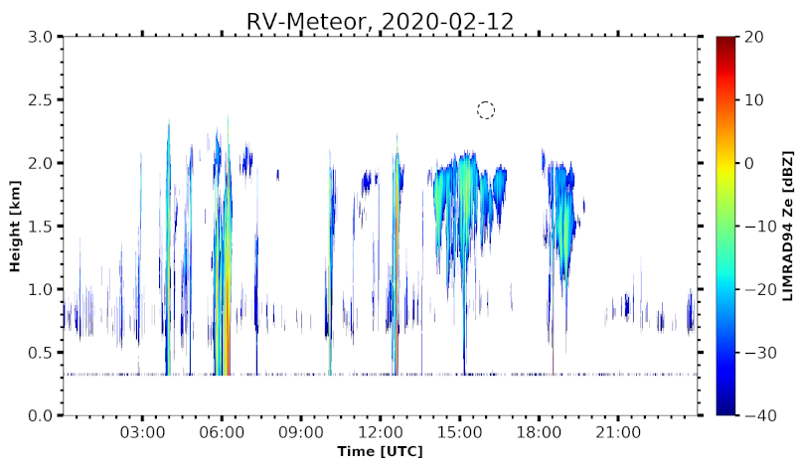

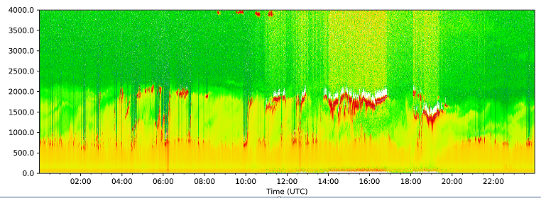

METEOR cloud radar and ceilometer data for Feb12

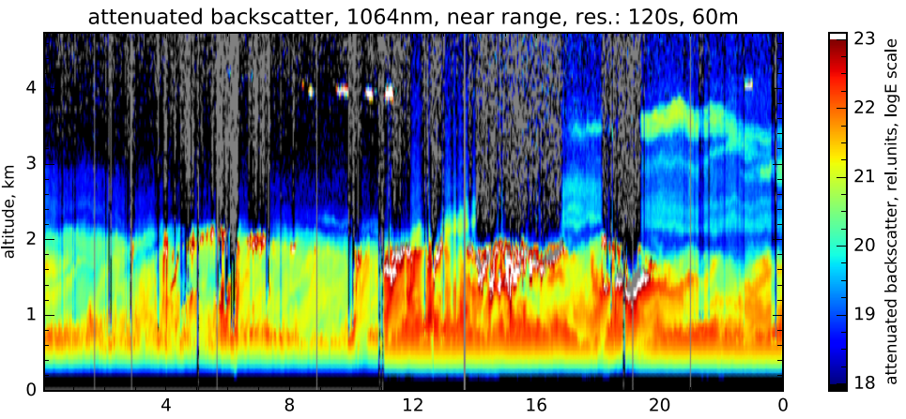

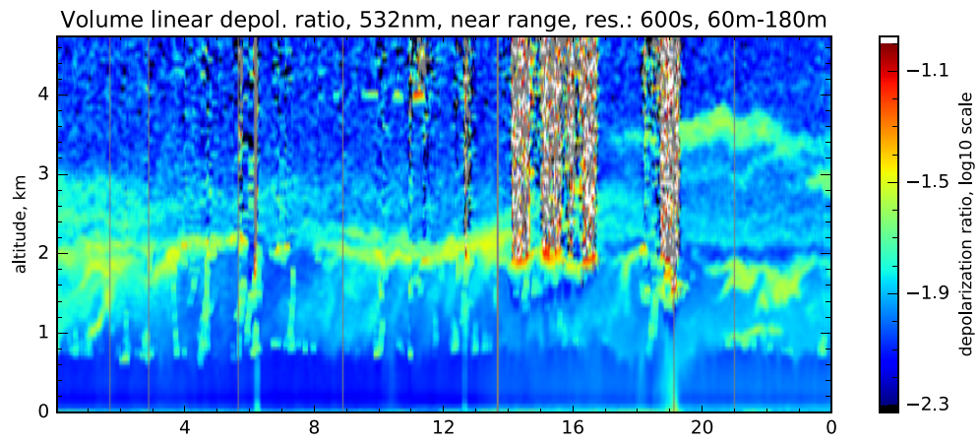

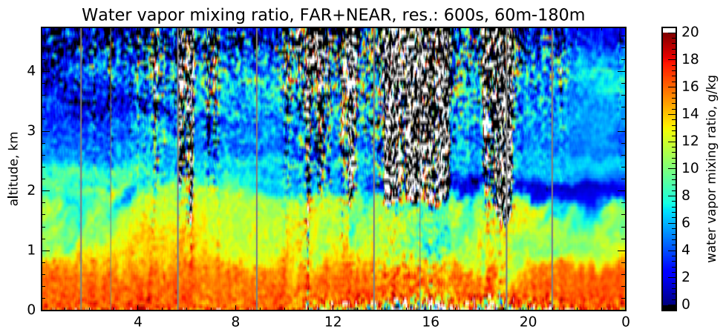

Raman Lidar data for Feb 12 (backscatter, depolarization, water vapor

Hourly average AOD (amount) and Angstrom parameter (inverse size) Jan 13- Feb12 on METEOR